**California’s geological hazard highlights in a fortnight**

Outline Itinerary

11th April to 21st April 2017



**YOUR responsibilities**

* YOU are responsible for arranging and booking your flights, and meeting us at LAX international arrivals, on Tuesday 11th April 2016 (early afternoon)[[1]](#footnote-1).
* Related to the above, YOU are responsible for any visas (if needed) and your ESTA.
* YOU are responsible for your own travel insurance.
* YOU are responsible for your wellbeing in the field (appropriate equipment, behaviour and ability to look after yourself).

**Meeting point:**

LAX international arrivals

**Accommodation**:

See overleaf

**Contact Info**

Philip Benson: +44 7733 32862

Derek Rust: +44 7786 413408

David Arnold (University of Portsmouth, School of Earth & Environment): +44 23 9284 2374

Trip summary:

|  |  |  |  |
| --- | --- | --- | --- |
| **Day #** | **Date** | **Journey** | **Evening stay at:** |
| 1 | 11/4/17 | Arrive LAX[[2]](#footnote-2) (approx. 15h);  LA – Santa Clarita | Santa Clarita (Super 8): 17901 Sierra Hwy, Santa Clarita, CA 91351  [wyndhamhotels.com](https://www.google.co.uk/url?sa=t&rct=j&url=https%3A%2F%2Fwww.wyndhamhotels.com%2Fsuper-8%2Fsanta-clarita-california%2Fsuper-8-santa-clarita-valencia%2Foverview%3FCID%3DLC%3ASE%3A20160927%3ARio%3ALocal&source=maps&cd=1&usg=AFQjCNE_jHEj7HHw4-zwNhs25vio_8pCpg&sig2=Mx4FyYdUMQ_-BhzDrBIlyQ&ved=1t%3A3443%2Cp%3AJcpGWLXxMoS1afagh6gF" \t "_blank) |
| 2 | 12/4/17 | Santa Clarita – Lancaster – Furnace Creek, Death Valley | Furnace Creek (Motel, across border in NV):  Death Valley Inn  651 US-95  Beatty, NV 89003  <http://www.bestdeathvalleyhotels.com/beatty-hotels-death-valley-inn.php> |
| 3 | 13/4/17 |  | *as above* |
| 4 | 14/4/17 | Furnace Creek – Bishop (Mono lake) | Bishop:  Holiday Inn express  636 N Main St,  Bishop, CA 93514.  <https://www.ihg.com/holidayinnexpress/hotels/us/en/bishop/> |
| 5 | 15/4/17 | Bishop – South Lake Tahoe | South Lake Tahoe (hotel):  Casino Centre Lake Tahoe  4107 Pine Boulevard South Lake Tahoe, CA 96150  <http://www.americasbestvalueinn.com/bestv.cfm?idp=1955> |
| 6 | 17/4/17 | South Lake Tahoe – Yosemite | Curry Village (cabins/tent):  9010 Curry Village Drive  Yosemite National Park, CA 95389  <http://www.yosemitepark.com/curry-village-cabins.aspx> |
| 7 | 18/4/17 |  | *as above* |
| 8 | 16/4/17 | Yosemite – San Francisco | San Francisco (Hostel):  Hostelling International, SF City Center  685 Ellis Street, San Francisco, CA 94109  [www.sfhostels.org](http://www.sfhostels.org) |
| 9 | 19/4/17 | SF – Paso Robles | Paso Robles (Holiday Inn express): 2455 Riverside Ave, Paso Robles, CA 93446  <http://www.hixpaso.com/> |
| 10 | 20/4/17 | Paso Robles – Santa Barbara | Santa Barbara (motel6): 443 Corona Del Mar  <http://www.motel6.com/reservations/> |
| 11 | 21/4/17 | Santa Barbara – LAX | ***Debrief***: Arrive LAX mid-late afternoon for flights in the evening (for those wanting lift to airport this day (if you want to remain in the US a bit longer, that’s up to you!) |
| 12 | 22/4/17 | Flight arrives | N/A |

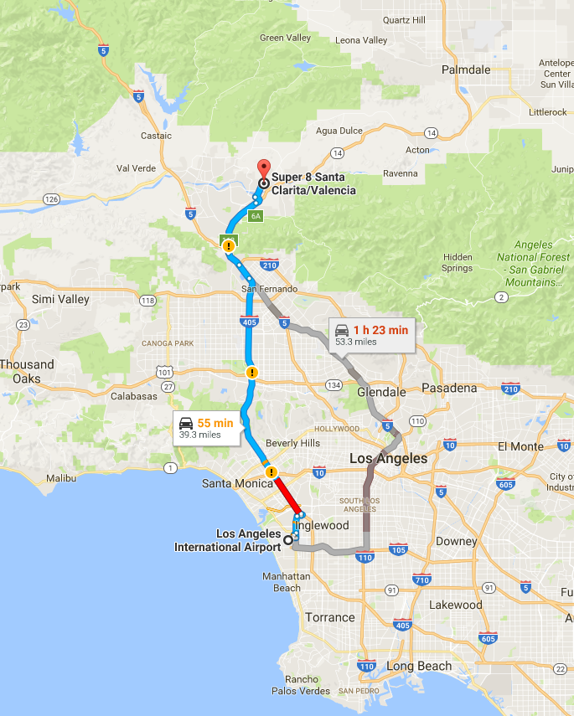**Day 1:**

Arrive LA International Airport [~14h] and collect two minivans.

Short drive up Hwy 5 to Santa Clarita, for briefings and dinner, and get the trip in order…

*Stay overnight in motel (Frazier Park) [39 miles; 55m].*

**Day 2:**

*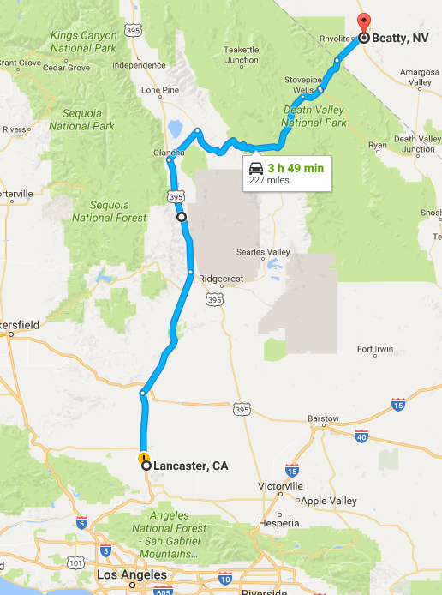Early start* on route 14N towards Palmdale and Lancaster, checking out California Aqueduct en route. Head W to Quail lake/Bald Mountain/Gorman area for a stop: discuss the San Andreas fault zone, uplifted mountains, numerous landslides and fault scarps. After quick (packed!) lunch, return to Lancaster ~14h for the *long drive* North on Hwy 14 towards the southern end of Owens Valley, stopping quickly mid-journey at Fossil Falls, where Holocene lavas dammed the Owens River. Discuss consequences of LA water demand for Owens Lake.

*Motel, death valley (Beatty, NV) [227 miles; 3hr 49]*

**Day 3:**

Day exploring Death Valley: Including classic faulted alluvial fans at the foot of the Black Mountains, Badwater, Dante’s View, whaleback structures, Panamint alluvial fans, Ubehebe crater.

*Motel, death valley (Beatty, NV)*

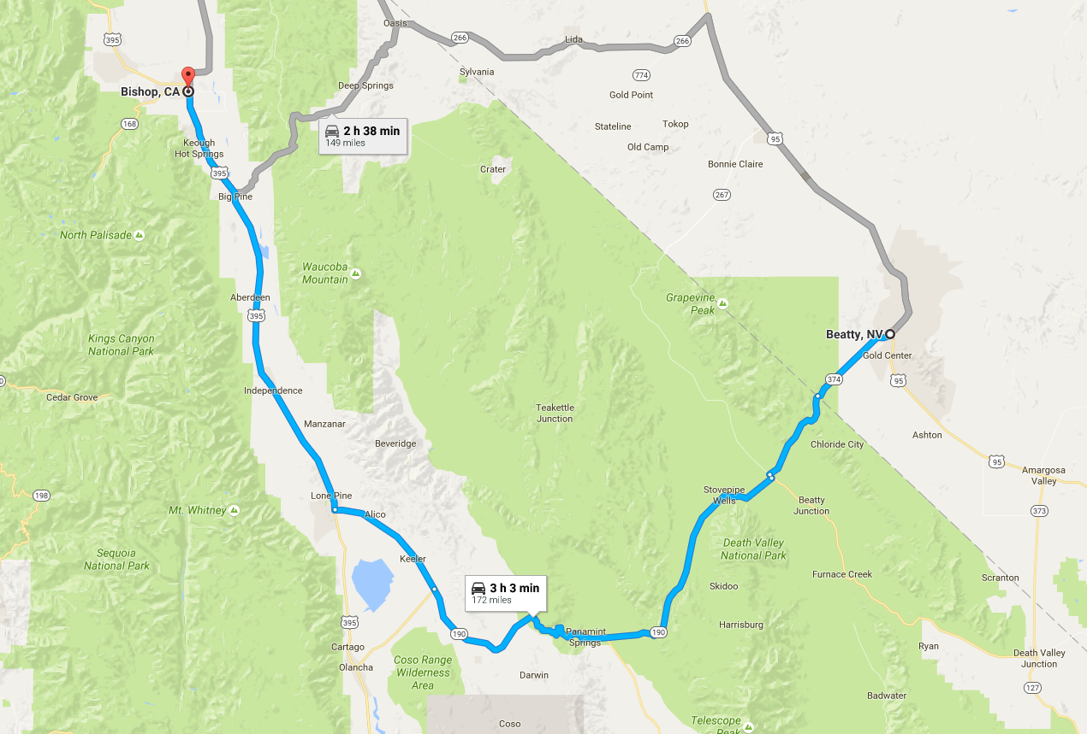

**Day 4:**

Leaving Death valley towards Lone Pone, including evidence for 1872 Lone Pine earthquake, and the faulted fan w of the town. Drive N on Hwy 395 to Bishop, noting very impressive E face of Sierra Nevada. Around Bishop check spectacular exposures of Bishop Tuff from the resurgent Long Valley caldera eruption ca 650 k ago.

*Overnight in Bishop. [172miles; 3h3m]*

*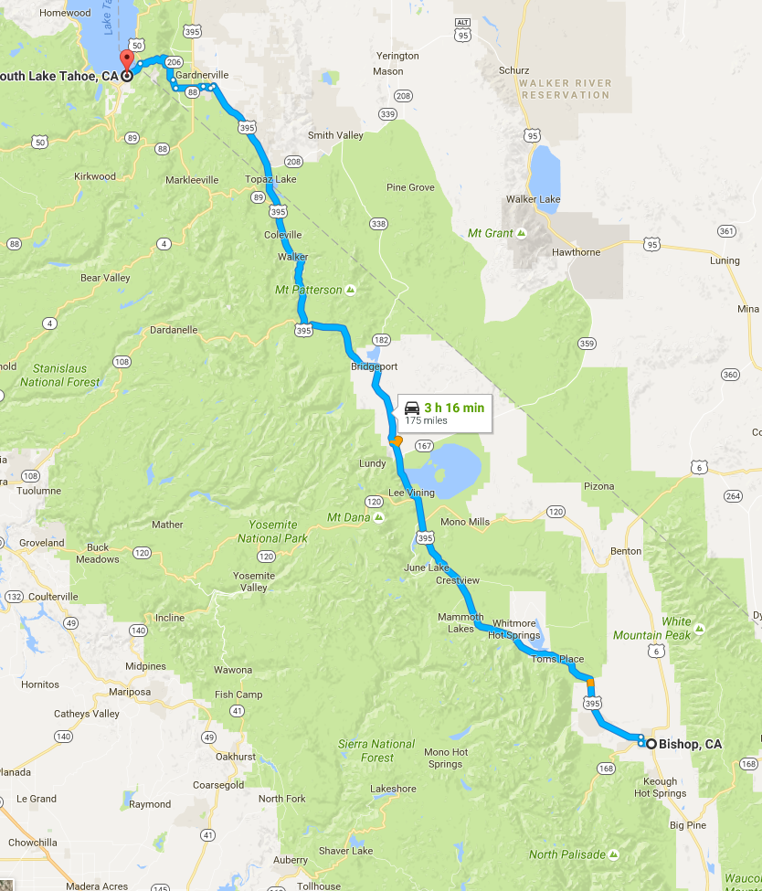*

**Day 5:**

Leaving Bishop to the North to see “textbook” roof pendants visible in the Sierra batholith to McGee Creek, where frontal faults have spectacularly displaced Holocene moraines.

Drive up 395 to South Lake Tahoe, via Lee Vining and Mono Lake. [175miles, 3h16m]

*Overnight in South Lake Tahoe.*

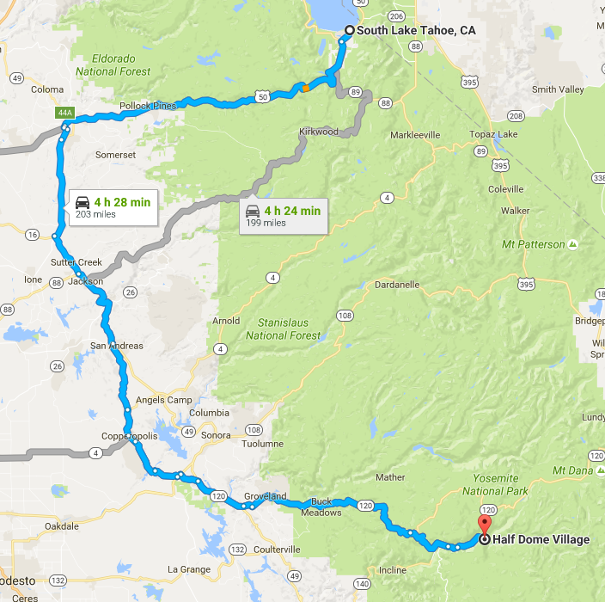

**Day 6:**

*Early start* to head South to Yosemite for 2 night stay: descending first into Placerville to see effects of the alluvial gold mining on large scale, and along rte49, which follows roughly the “mother-lode” quartz vein form actions that drove the rush. *Camping[[3]](#footnote-3) in Yosemite (curry village). [203miles, 4h28m].*

**Day 7:**

2nd Day spent exploring Yosemite: Discuss 1982 earthquake, stress transfer and its influence on the Parkfield earthquake prediction experiment

**Day 8:**

Exit Yosemite on 205 to San Francisco: descend into the Central Valley. Afternoon “off”! *Overnight in San Francisco*, discuss effects of 1906 and 1987 earthquakes, and mitigation measures, e.g. BART. *[188miles 4h39m]*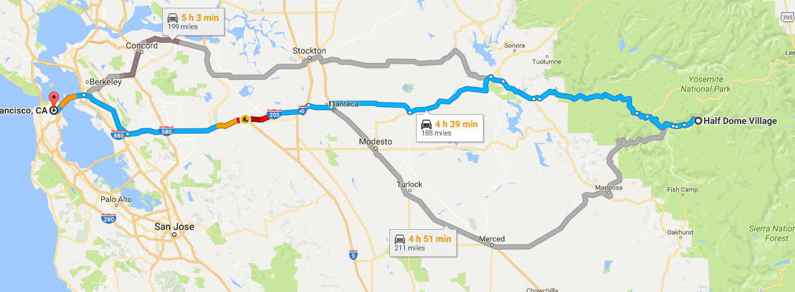

**Day 9:**

Visit to the famous city of Parkfield, then South *towards Paso Robles for overnight stay.*

*[218miles, 3h48m].*

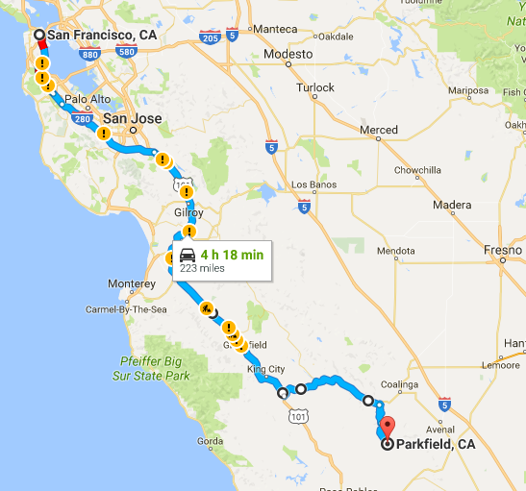

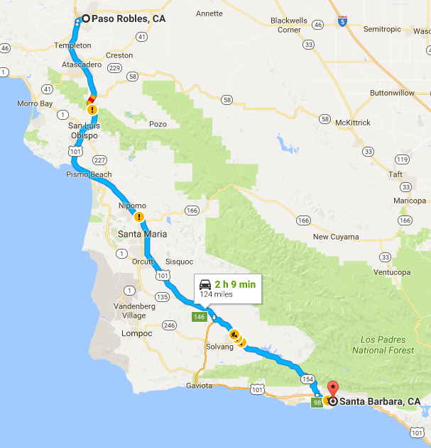

**Day 10:**

Leaving Coalinga and onwards to the Corizo Plain and a visit to the Wallace Creek SA site for a field exercise. Continue S across Santa Ynez Mtns (San Marcos Pass) to *Santa Barbara for overnight stay. [194 miles 3h 15m].*

**Day 11:** Hwy 101 from Santa Barbara to LA International for return flight. *[96 miles 1h46m]*

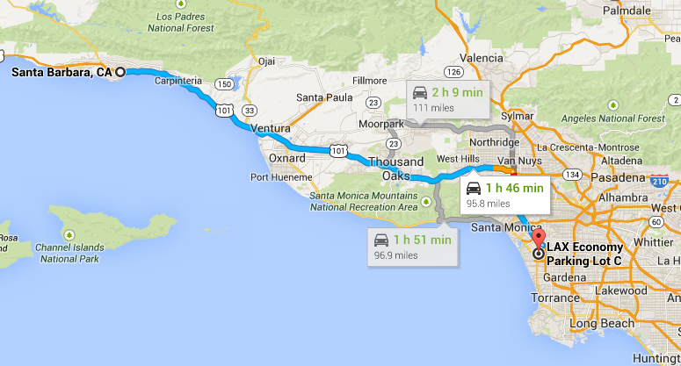

**Day 13:** Arrival back in UK…

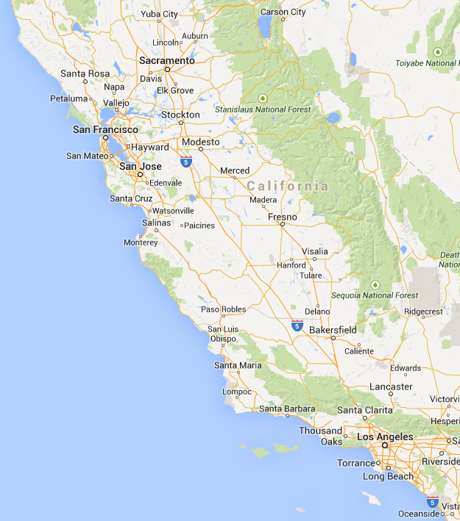

**(total: 1341 miles, 13 days: LAX-Frazier-Lancaster-FurnaceCreek-Bishop-SouthLakeTahoe- CurryVillage-SanFran-PasoRobles-SantaBarbara-LAX]**

1. Please note, precise details of meeting point and time, as well as accommodation, will be confirmed nearer departure time, and once numbers have been confirmed. [↑](#footnote-ref-1)
2. There are various flight options leaving LHR/London around 10h-12h for arrival ~15h [↑](#footnote-ref-2)
3. It’s not really camping: the pre-assembled tents/cabins are fully equipped, but you’ll need a head torch, say. [↑](#footnote-ref-3)